For Spring Soccer Registration
Registration URL: http://ksu13503001.siplay.com or for more info visit our website http://www.krajisnikfc.soccershift.com/club-froms
If you would like to register yourself or your children to volunteer, or to play with the league, you will need to create your own account.
Questions? Call/Text Anel Pajazetovic or Email krajisnikfootballclub@gmail.com
Already have an Account:
1. Log in to your Family Member Account.
2. Click on the Register to Play/Participate or the Apply to Coach/Volunteer button. (Go to Page 3)
If you don’t have a SI Play account:
3. Click Create Account.
4. Fill out the required information.
5. Please fill out the required login requirements for you new SI play account.
Go to the clubs SI play website and click the log in button:
Create an Account as new user / if you already have an account, please log in with your credentials.
Create New Account fill in all personal information. This part is for the parent not the player.
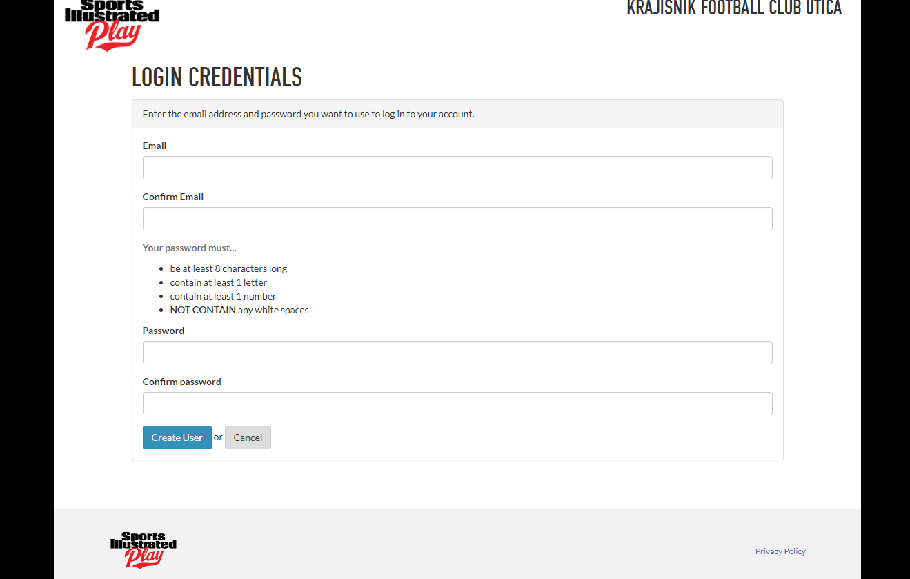
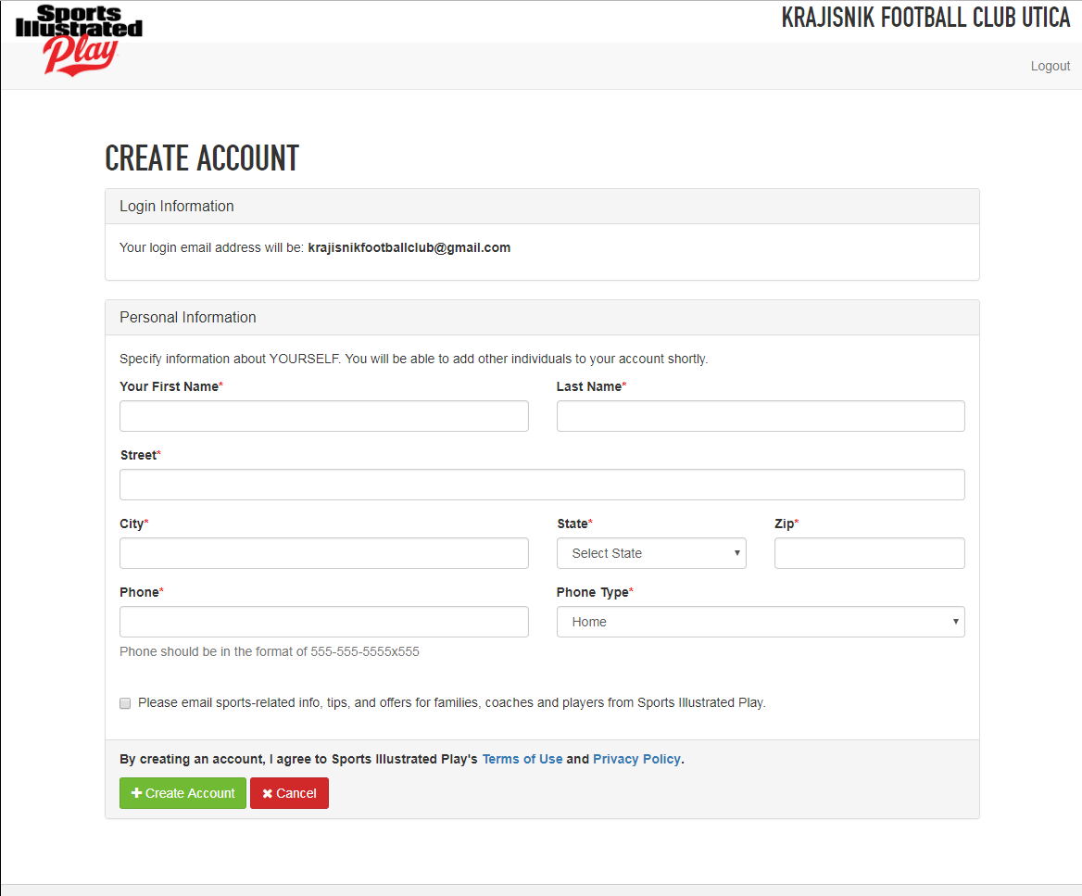
Players click on Register to play/participate. For coaches click on apply to coach/volunteer.
Add player to the account
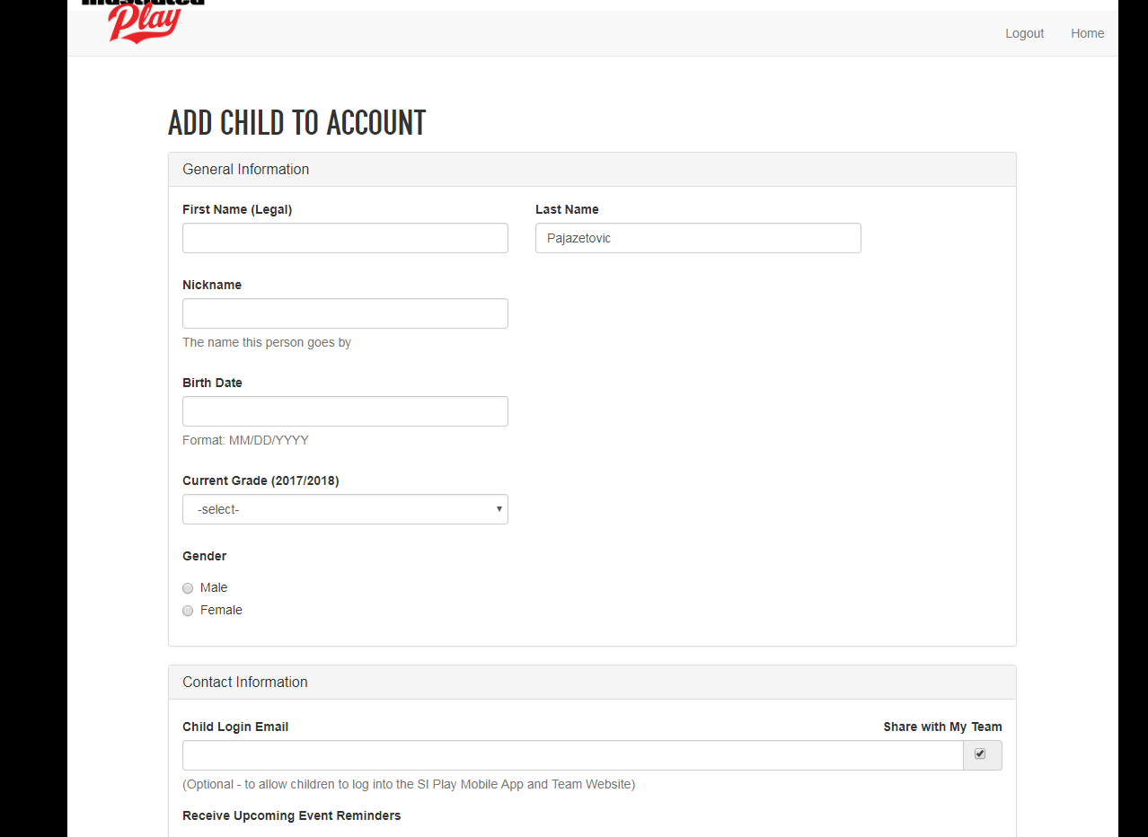
Select league your child will be playing in. 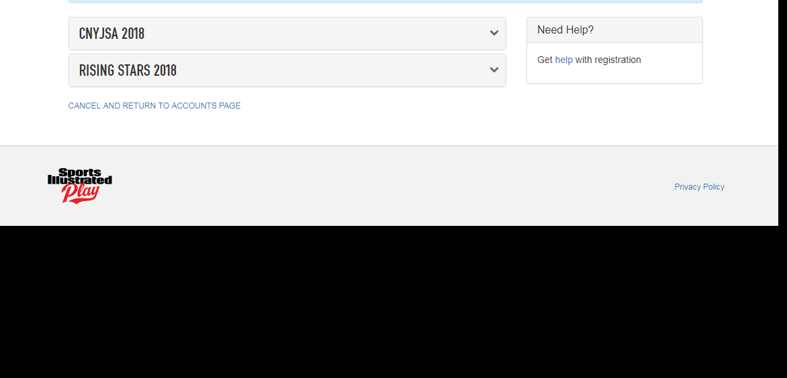
Select Age group and team.
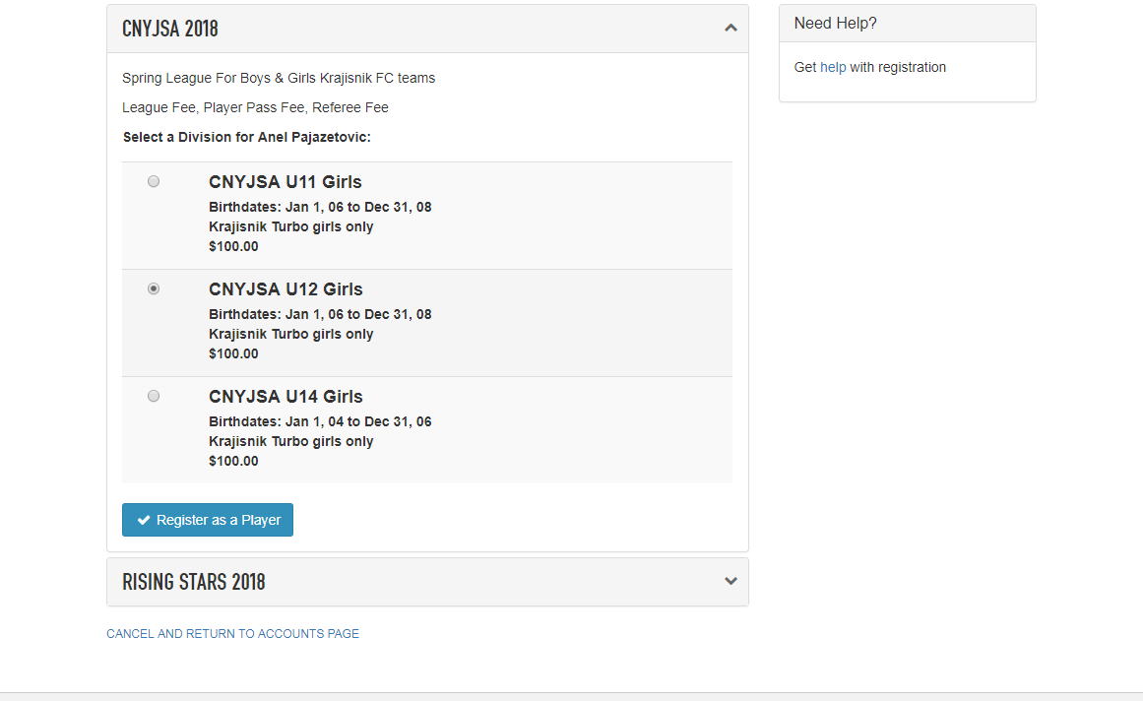
Upload picture, unless the coach as a picture of the player, than you can skip this part.
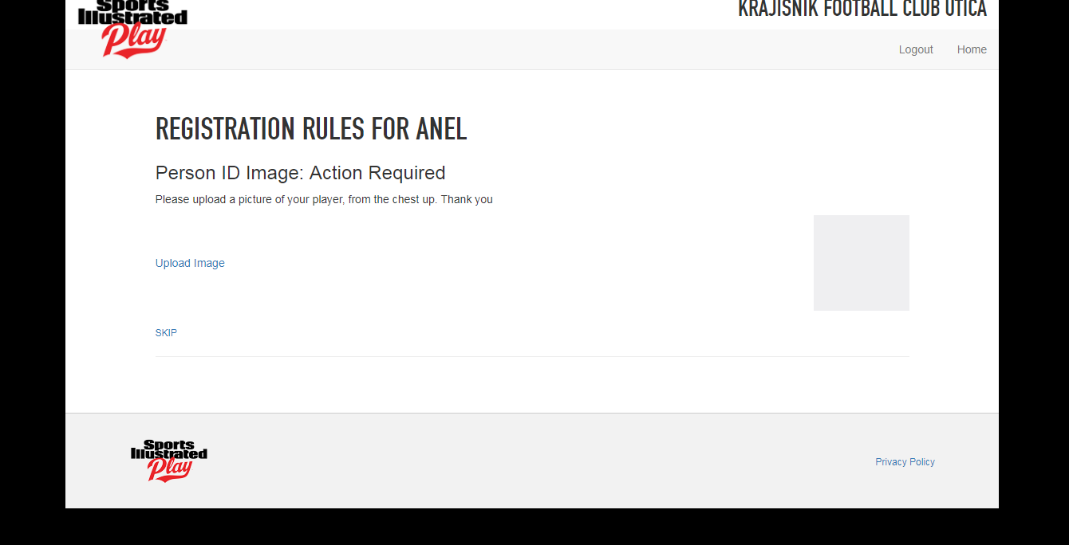
Call Anel, if you aren’t sure if Krajisnik Football Club has a picture of your child. Click Continue
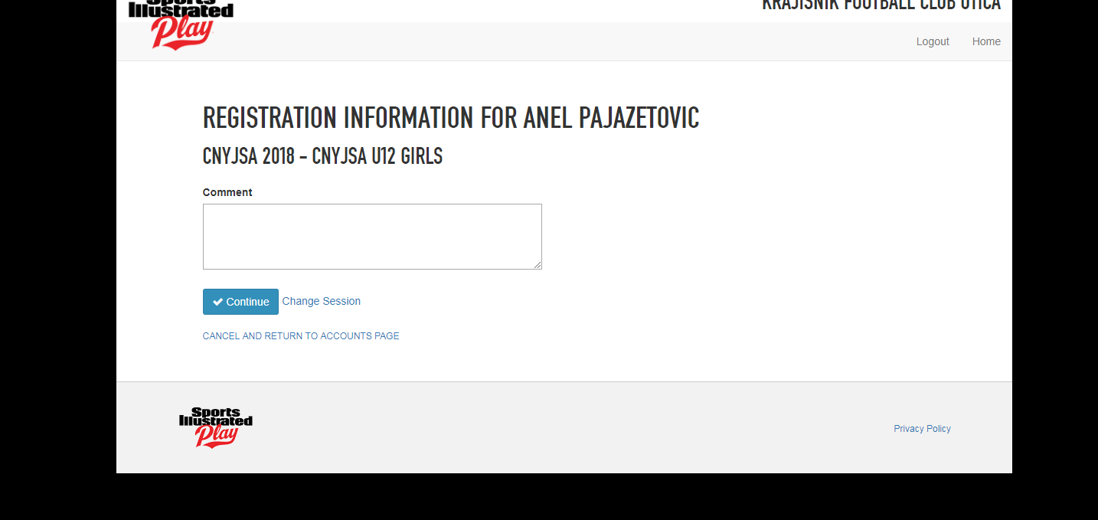
Please add emergency contact to the account. (The system might ask for this part in the beginning or in the middle of signing up your child.)
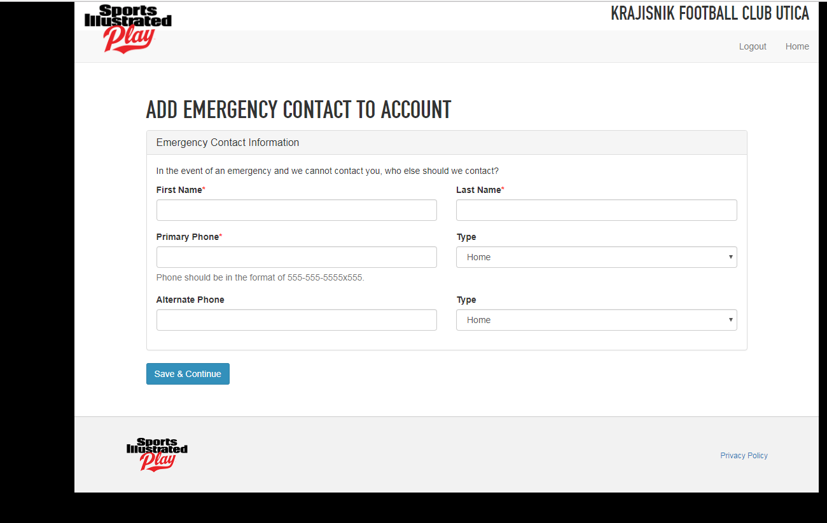
Checkout.
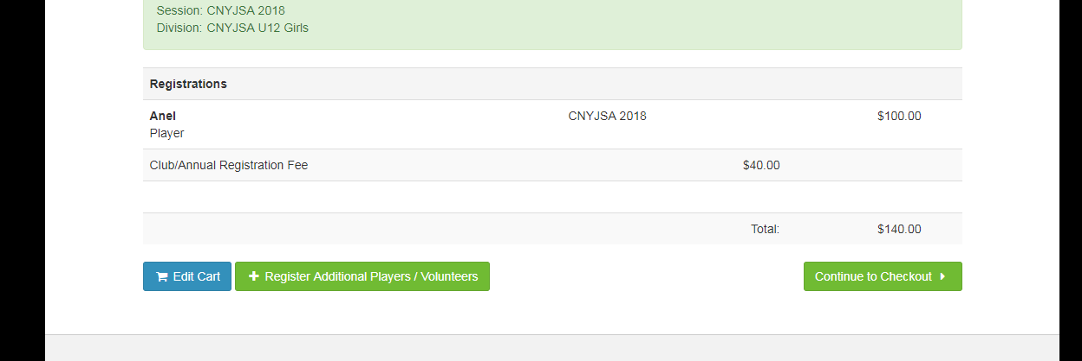
Select yes or no for reimbursement protection/agree to the terms and conditions. Than choose payment method.
